**Bambu website UI Update Feb. 22**

**Hello guys,   
We might have had some communication problems regarding how the website should look, so I made a visual aid so it can help you guys get an idea of what we want exactly, and also some bugs we found recently and things that need to be added in the website.  
  
1. Add email in the registration page, when we tried to recover the password we encounter an error. See image below**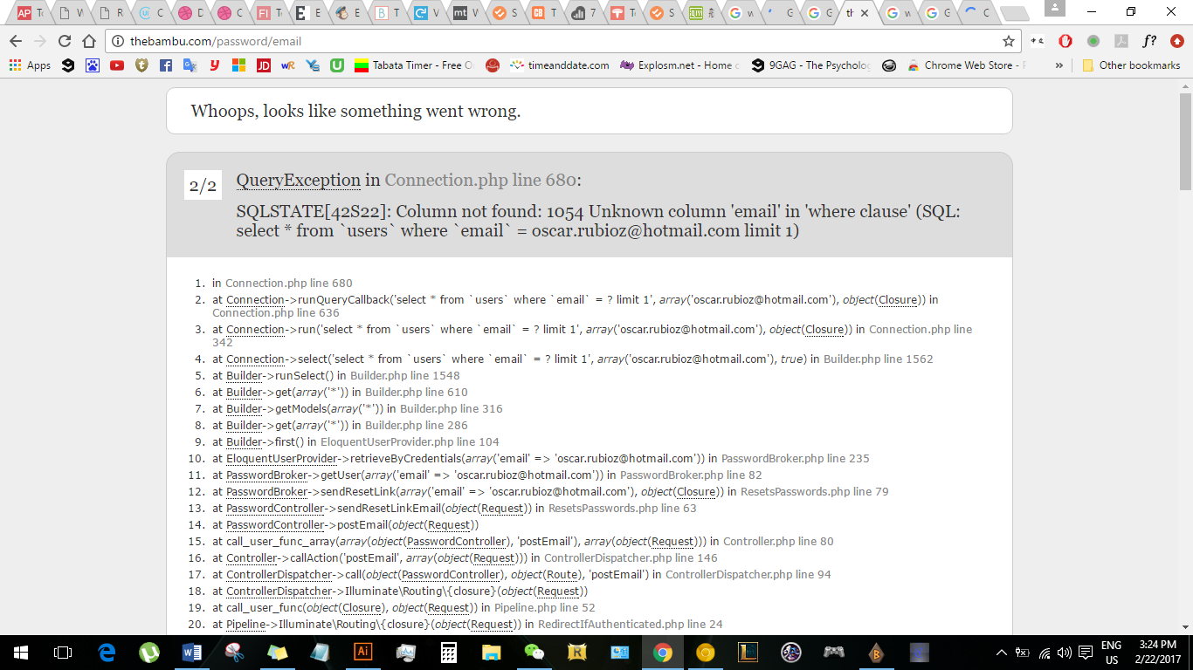

**2. Homepage**

**This is how we want the homepage to look, add the categories on the left side, for now it’s just for aesthetics.**

**Font for “Bambù” title is called: Milkshake**

**Main font: Nexus Bold and Nexus Light.**

**If you can’t find the font online, make sure to let me know and I’ll send it to your email.   
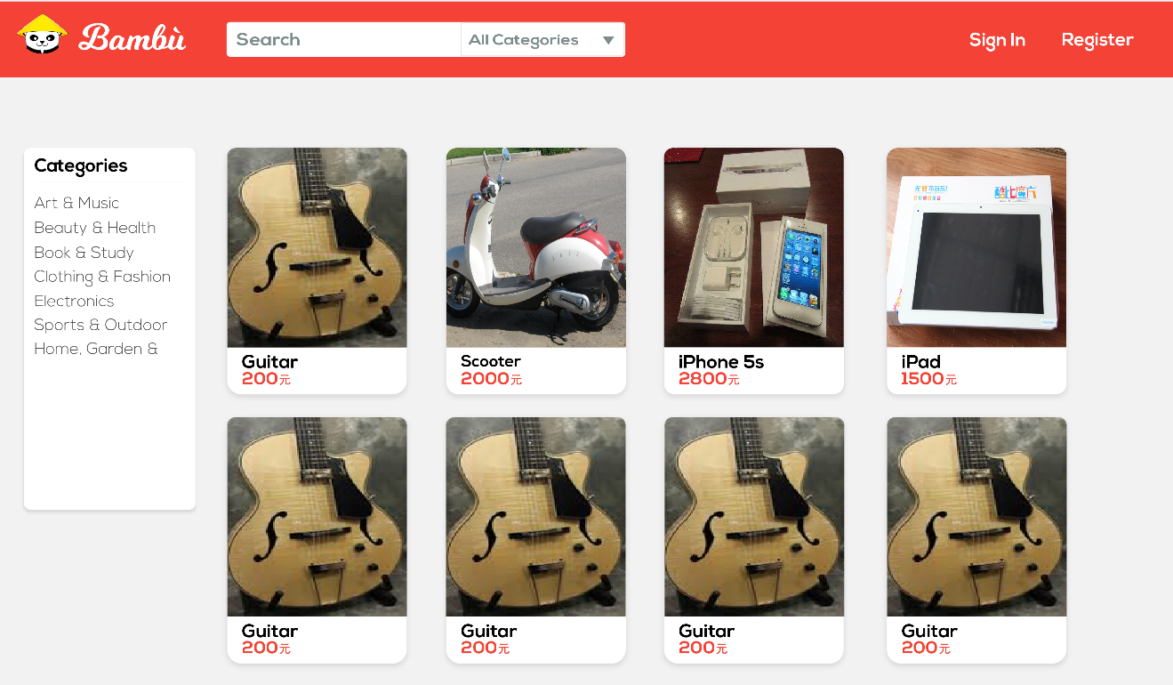**

**3. Uploading an item**

**When uploading an item this is how we want it. Round corners of the rectangle. If you can’t make the “+” with a circle, let me know and I’ll send the image to your email.**

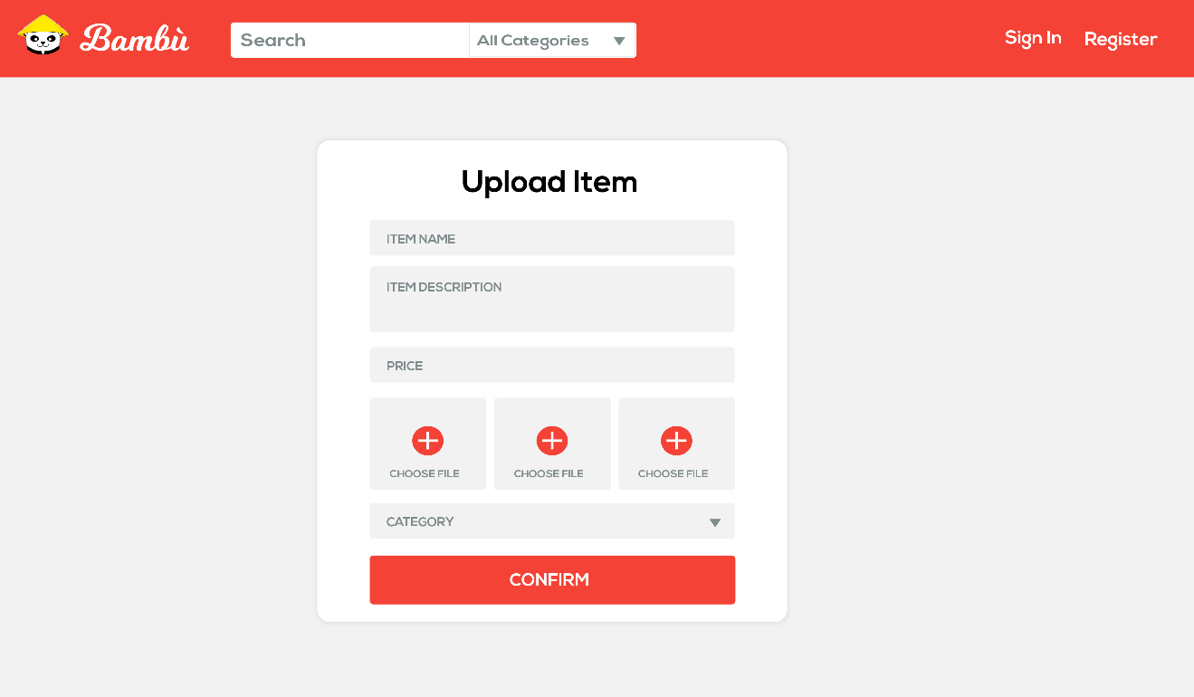

**4. Update profile**

**Here we also need you to add the address, for other users to check how far the seller is or vice versa.**

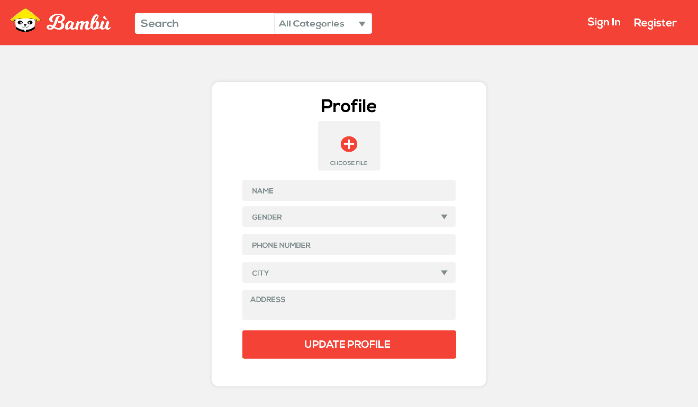

**5. Sign in / Register**

**The Sign in and Register part we don’t want it to take the whole page. Make it pop up on the home page with a dim background and also able to go back to the homepage just by clicking anywhere outside the “Sign in square”.**

**Make sure to add email option on the registration page, in order to recover the password.**

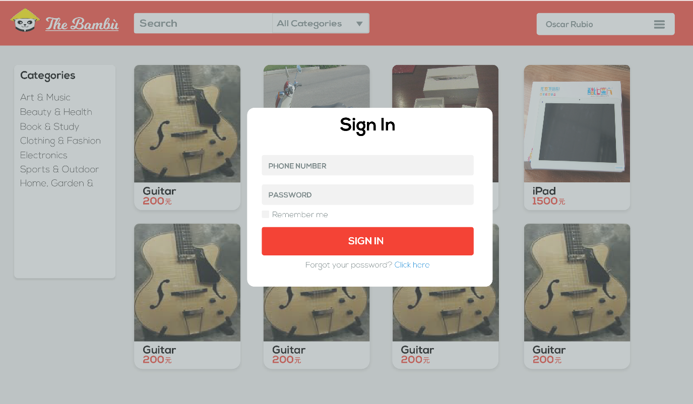

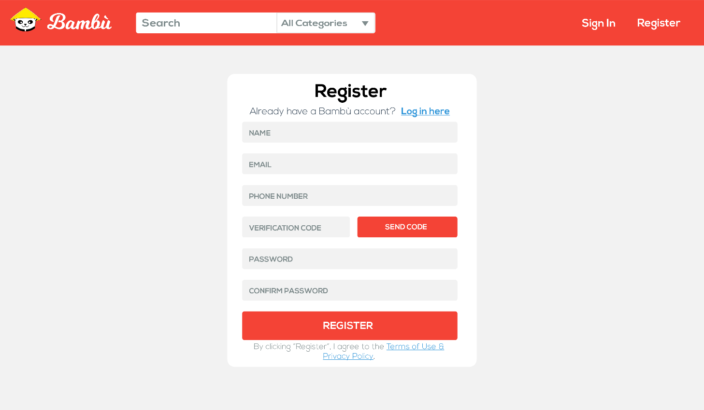

**6. Change password / Forgot password**

**We also want this parts to be pop up once you click on “Forgot password?”**

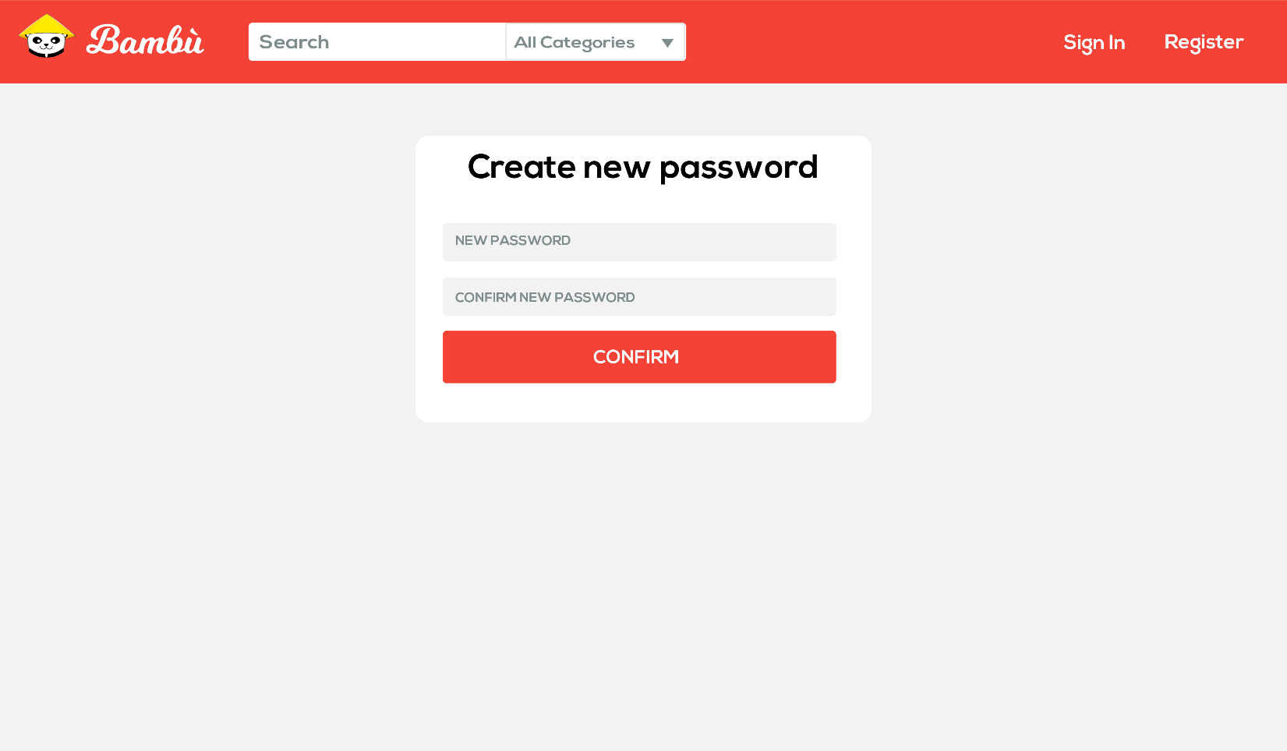

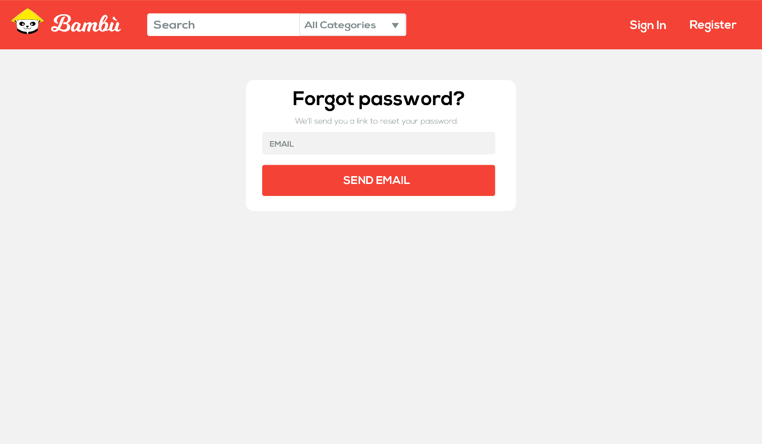

**7. Registration complete**

**Once the registration is complete this is the message we want after you’re done.   
*I’ll send you the image to you email.**

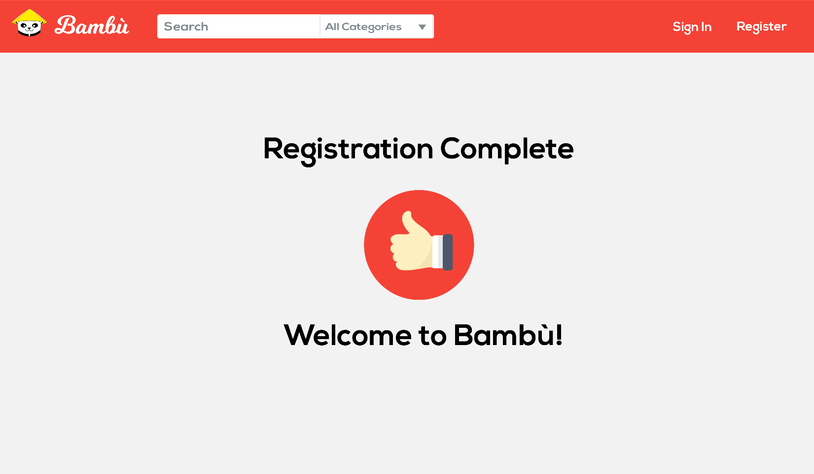

**8. Profile Drop bar**

**This is the new drop bar we want to add on the website.**

**I’m not sure if this website might help you with the process but you should check it out.**

[**http://codepen.io/asellenrick/pen/JHzDx**](http://codepen.io/asellenrick/pen/JHzDx)

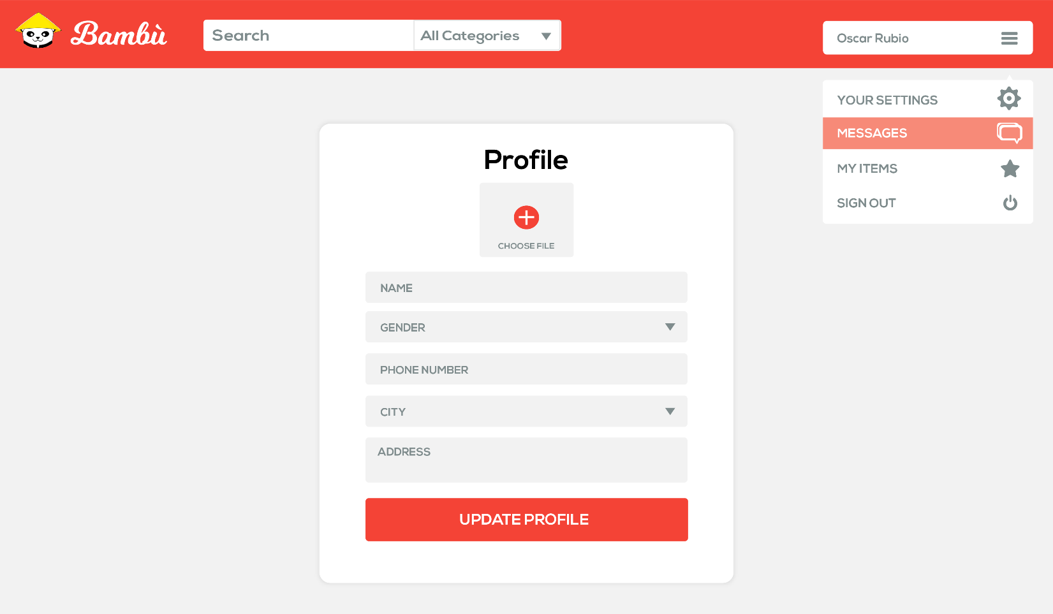

**9. Messages**

**We would also want this Popping out once you click on “Messages” so you can see your new messages and/or old messages.**

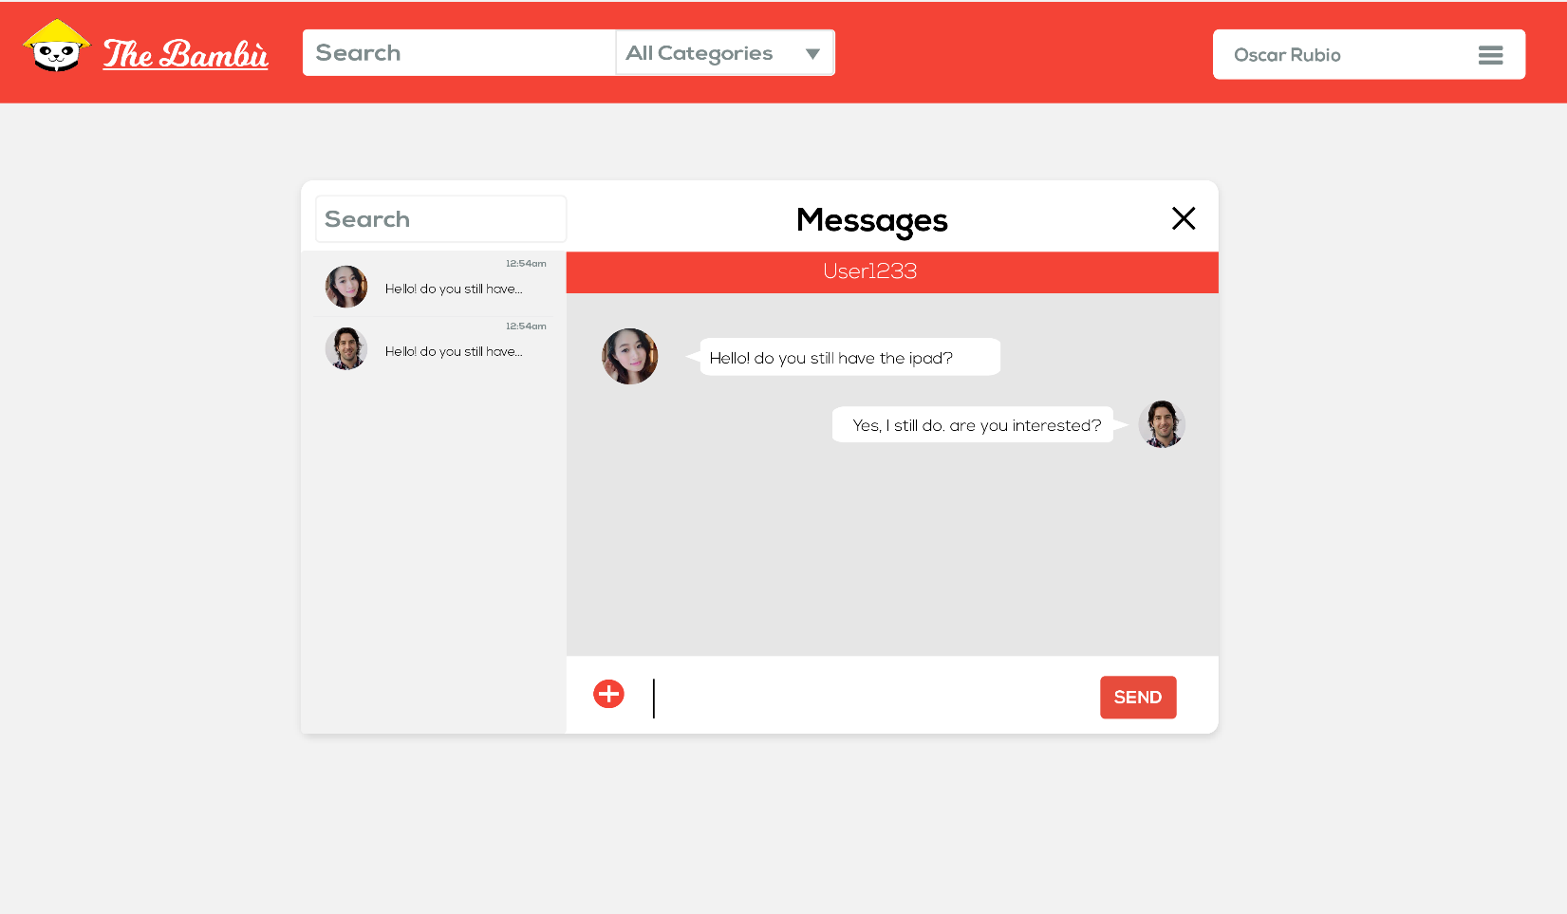

**10. Chat box**

**The chat box should be on the right side of the website, similar to Facebook.**

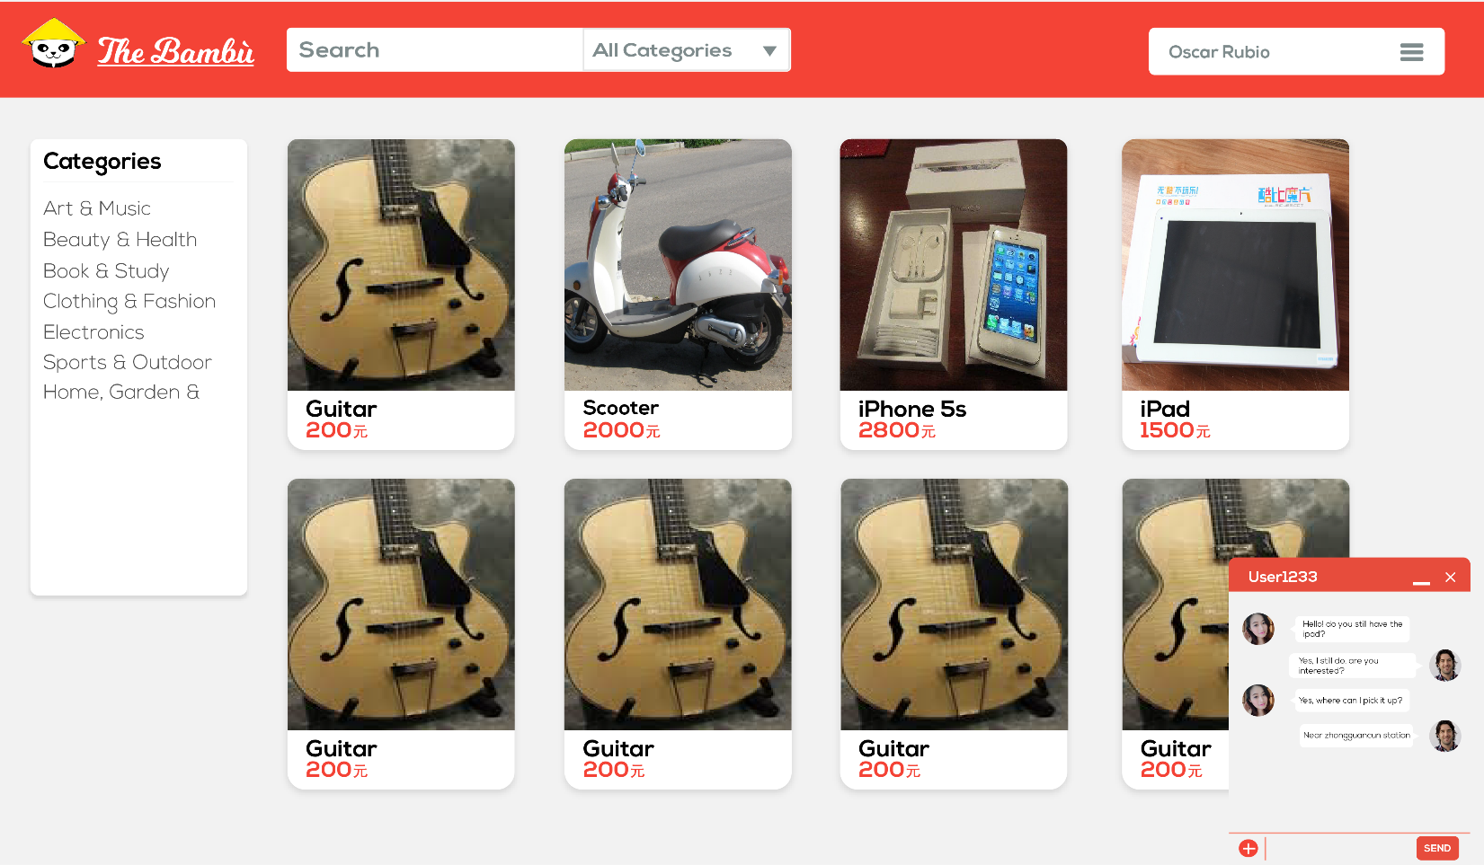

**11. Shadow effect**

**Every box or item box should have a drop shadow similar to the image below to give a certain popup effect. You can find more detailed info on what we want.**

[**https://codepen.io/sdthornton/pen/wBZdXq**](https://codepen.io/sdthornton/pen/wBZdXq)



**FONTS**

**Bambu title: Milkshake**

**Main font: Nexus bold & Nexus Light**

**COLORS**

**Homepage background: #f2f2f2**

**Search bar : #7f8c8d**

**Search bar once written: Black**

**Main color red: #f44336**

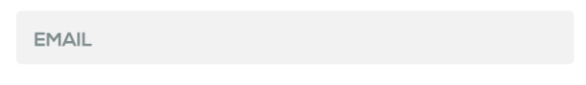

**Inside the fill boxes: #7f8c8d**

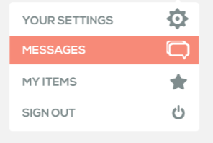

**Color for drop bar: #f78a78**

**Drop bar text & icons : #7f8c8d**